Kimberly Orozco
CSD430-T301
March 20, 2026
Module 1.2 Assignment GitHub
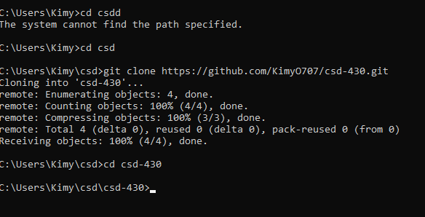
My command prompt process.
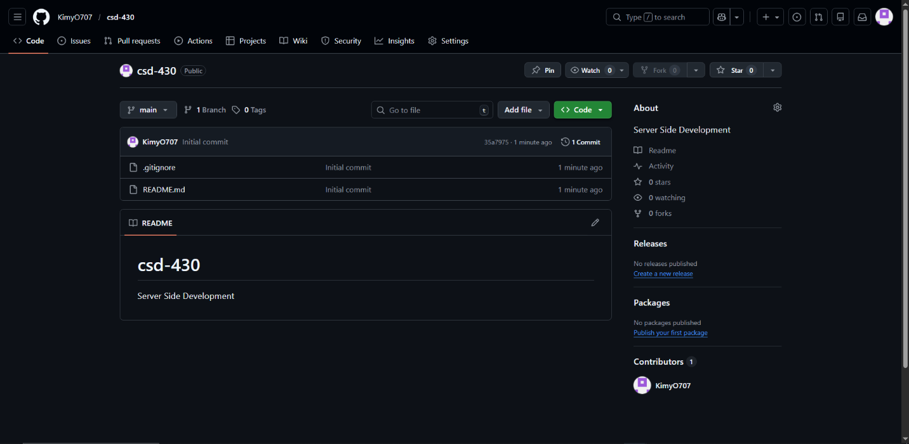
My repository.
GitHub link: https://github.com/KimyO707/csd-430

